Full name: ________________________
ID:

Project title:
STUDY ON THE PEOPLE’S PERCEPTIONS AND FINANCIAL CONTRIBUTIONS TO THE MANAGEMENT AND TREATMENT OF DOMESTIC WASTE IN THE RED RIVER DELTA VIETNAM

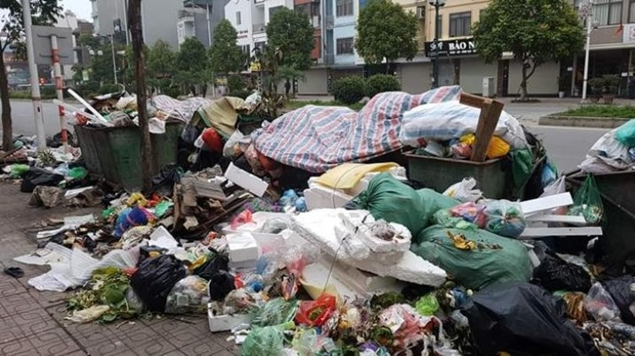

Structure of the questionnaire |  | # of question | Pages
Part A | Demographic Information of Interviewees | 6 | 2
Part B | Current Status of Household Waste Pollution | 6 | 3
Part C | Current Status of Waste Collection and Treatment | 4 | 4
Part D | Perception and Evaluation of Waste Collection and Treatment | 3 | 5
Part E | Requirements and Suggestions for Improvement | 4 | 6
Total |  | 24

June, 2025
Hanoi, Vietnam

Part A: Demographic Information of Interviewees
- What is your age?
21-30 31-40 41-50 51-60 >60
- What is your gender?
Male Female Other
- What is your highest education level achieved?
Secondary school or below High school Technical school/College degree
Bachelor’s degree Master’s degree Doctoral degree
- What group does your household belong to according to its current economic conditions?
Poor households
Near‑poor households
Middle‑income households
Upper‑middle‑income households
High‑income households
- How much is your household income?
<1 30-40
1-3 40-50
3-5 50-60
5-8 60-70
8-10 70-80
10-15 80-100
15-20 >100
20-30
- What is your current place of residence?
Urban area Rural area

Part B: Current Status of Household Waste Pollution
- Does your household detect any odors from the waste collection site?
Yes No

- How often does your family smell odors from the waste collection site?
Not often Normal Regular

- How do you evaluate the level of household waste in places that are not waste collection points (such as vacant lots, ponds, lakes, roadsides, etc.)?
Occurs frequently Occurs rarely Does not occur

- To what extent does environmental pollution from waste affect your life?
Strongly affected Affected Normal Not affected

- Compared to previous years, how do you assess the level of household waste pollution in your area?
Worse No change Better

- What are the causes of increasing rural waste pollution?
Population growth
Increasing living demands
The development of production and daily activities increases waste generation
Limited public awareness
Industrial waste increases pollution
Household waste increases pollution
Low infrastructure
Other

Part C: Current Status of Waste Collection and Treatment
- Have the waste collection personnel adhered to the designated collection schedule?
No Yes Don't remember/No opinion

- Does the local waste collection site sort waste at source before transporting it to the transfer station?
No Yes Don't know

- Is household waste transported to the designated aggregation site in compliance with regulations?
No Yes Don't know

- Does your residential area have public waste bins?
No Yes Don't know

Part D: Perception and Evaluation of Waste Collection and Treatment
- How satisfied is your family with local waste collection activities?
Very dissatisfied Dissatisfied Normal Satisfied Very satisfied
- How satisfied is your family with local waste treatment activities?
Very dissatisfied Dissatisfied Normal Satisfied Very satisfied
- How would you evaluate the quality of household waste collection, transportation, and treatment services in your residential area on a ten‑point scale?

Part E: Requirements and Suggestions for Improvement
- Do you want to improve the collection, transportation and treatment service of household waste?
Yes No
- Do you think the current monthly waste collection fee is reasonable?
Very unreasonable Unreasonable Normal Reasonable Very reasonable
- Would you be willing to pay a higher fee to improve waste collection and treatment services?
Yes, I'm ready No, I’m not ready
- What is the maximum amount your household is willing to pay to enhance waste services? (Unit: VND 1,000 per household per month)
20 400
40 500
80 600
100 700
120 800
160 900
200 1.000
300

